Main Headings Sub Headings Sub-Headings (Description)

# **Main Objective**

Our main motive was to find an easier solution to measuring lengths and distances.

# **Introduction**

This project’s main implementation was of the HC-SR04 Ultrasonic Sound Sensor, LCD, Arduino Nano, Potentiometer, Main Switch, and a KY-008 Laser.

Team Members:

1. **Mohammad Yehya Hayati K21-3309**
2. **Rafed Naeem K21-3385**
3. **Hasan Iqbal K21-3206**

# **Methodology**

## **Code for Reference (Hardware is Given Below):**

## 

## **Initialization:**

Line 14: We have selected low output because we aren’t sending anything.

## **Sending Sound Waves:**

Line 16 & 17: we are executing a 10-microsecond delay.

## **Taking Sound Waves as Input:**

Line 19: we have turned on the echo pin to detect any input.

## **Calculation:**

Line 20: calculating the distance between sensor and object that rebounded the sound wave.

## **Display:**

Line 21 to 25: Displaying the Distance calculation on the LCD.

## **Clearing Display:**

Line 27 to 30: during the display of clear LCD, any previous output does not interfere with any current output.

## **Hardware:**

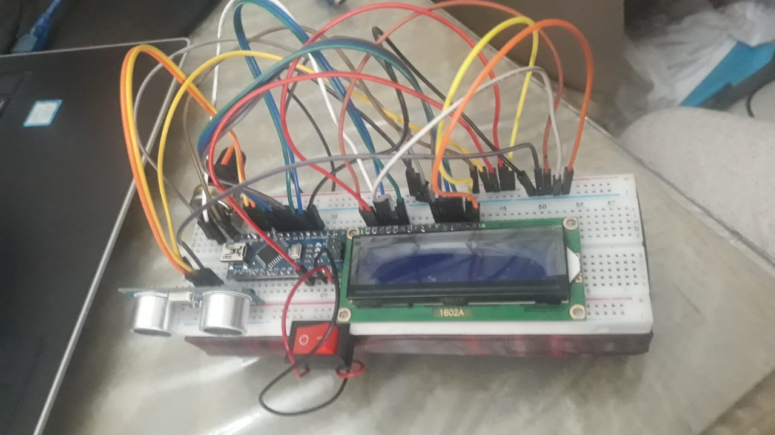

LCD Display

HC-SR04 Ultrasonic Sound Sensor Main Switch

Wires Arduino Nano Potentiometer

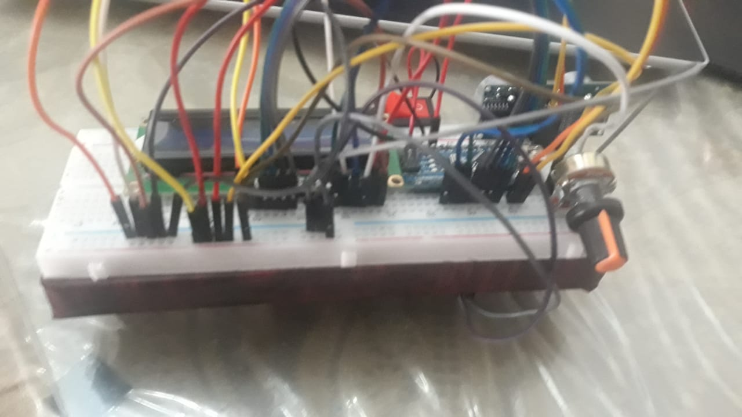

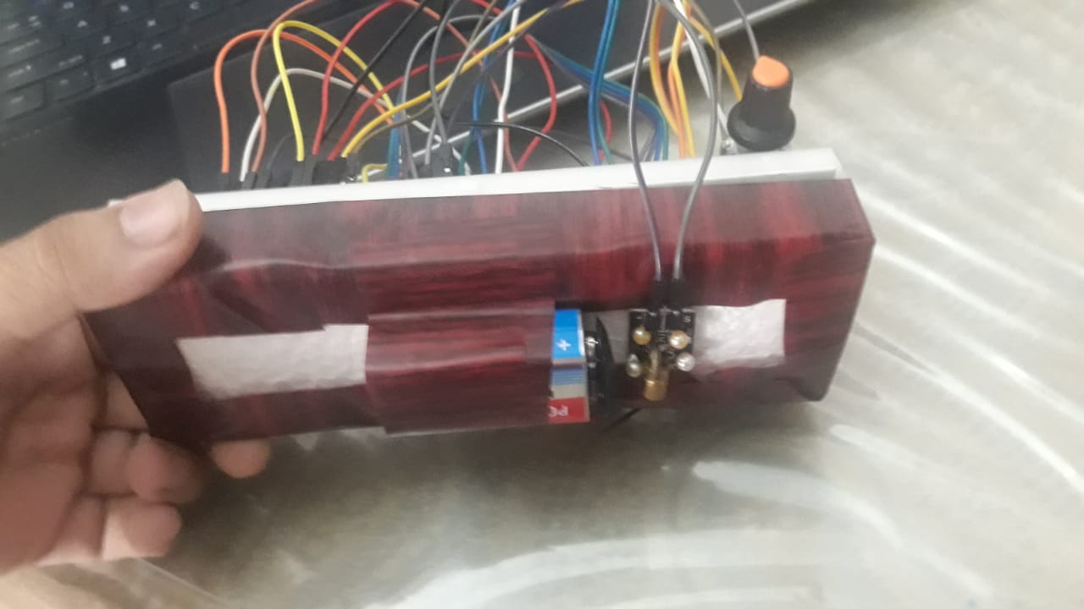

Battery KY-008 Laser

## **Working Principle**

The working of the hardware side of the project goes hand-in-hand with the software side, so it is important to keep an eye for both parts of the project.

First of all, to open the contraption we need to switch on the Main Switch which will allow the battery to supply voltage and ground to the Arduino Nano which in turn distributes voltage to the whole circuit. The code given above is stored in the Arduino and is controlling the other parts attached to it. The HC-SR04 Ultrasonic Sound Sensor is the first that works as seen in the code, and it generates a sound wave that will be received as an echo after 10 microseconds. Once this is done we will turn off (Output Low) the HC-SR04 Ultrasonic Sound Sensor to avoid any confliction between the calculations. Then we use the common formula:

$$S=VT$$

$$V=Velocity , S=Distance , T=Time Taken$$

However, since the time taken is for a sound wave to move twice the distance we will divide by two, hence:

$$S=\frac{VT}{2}$$

Since we are assuming that the speed of sound is constant we will consider:

$$V=0.0343 cm/μs$$

Therefore: $S=0.0343*\frac{T}{2}$

Once our distance is calculated all we need to do is to output in on the LCD screen and give a delay to

# **Findings of Experiment**

## **Results:**

The final result looks something like this:

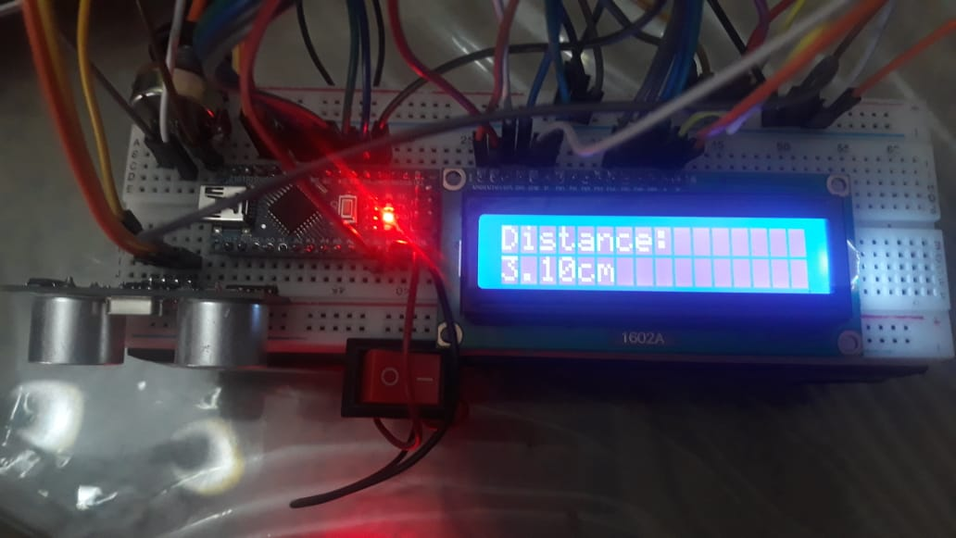

The output could be a little more accurate if we included a DHT11 Humidity and Temperature Sensor however it would call for a little more complex working. In the end it is a satisfactory result.

## **Challenges:**

* Soldering was quite difficult as it required a tremendous amount of focus on each pin.
* Pins were not correctly attaching to the components.
* LCD was displaying garbage values at random intervals of time.

# **Application**

The need to use measuring tape is outdated for these calculations so we required a new more pragmatic way to measure distance.

If correctly configured it can also act as an MRI machine.

# **Conclusion**

We are grateful to be given this opportunity to evolve our thinking process. In conclusion, we are extremely happy with the finished product and are sure it will be evaluated and rated highly among the other projects in our batch.